Experiment – 2.2.2
Student Name: Himanshu Goyal | UID: 24BDA70369
Branch: CSE (Data Science) | Section/Group: 24 BDS-4(B)
Course: Full Stack II (24CSP-337) | Date of Performance: 16-09-2026

1. Aim:
To optimize backend read operations using caching and efficient database query strategies.
2. Software Required:
• Programming Language: Java (JDK 17 or higher)
• Framework: Spring Boot with Spring Cache Abstraction (spring-boot-starter-cache)
• Database & ORM: H2 In-Memory Database / PostgreSQL with Hibernate ORM
• Caching Provider: ConcurrentMapCacheManager (In-Memory) / Caffeine Cache
• Testing & Benchmarking: PowerShell Measure-Command / JUnit 5 SpringBootTest
3. Objectives:
• To identify and resolve inefficient database queries: specifically resolving the infamous N+1 query problem.
• To eliminate multiple round-trips: using JPQL JOIN FETCH to eagerly retrieve parent and child entities in a single query.
• To implement declarative caching: using @Cacheable, @CachePut, and @CacheEvict to minimize database hits.
• To execute Native SQL aggregation queries: mapping database group-by analytics to Spring Data interface projections.
• To benchmark API performance: quantifying latency reductions under cold miss versus warm cache hit scenarios.
• Course Outcomes Mapped: CO4 - BT4, CO5 - BT5
4. Theory:
Read-heavy enterprise applications face significant scalability bottlenecks when ORM frameworks generate inefficient queries. The N+1 query problem occurs when loading a collection of N posts alongside their related child comments. The ORM executes 1 query to retrieve all posts, and subsequently executes N separate queries to fetch comments for each post (totaling N+1 round trips). This is eliminated using JPQL JOIN FETCH ('SELECT DISTINCT p FROM Post p LEFT JOIN FETCH p.comments'), which instructs Hibernate to join the tables and populate all entities in a single SQL operation.
In addition to query optimization, declarative in-memory caching stores hot read results in RAM, bypassing the persistence tier completely. Spring's caching abstraction uses @Cacheable to serve subsequent identical requests with sub-millisecond latency. To ensure cache consistency, @CacheEvict purges stale entries upon post modification or deletion, while @CachePut updates values dynamically. For complex analytics involving GROUP BY and COUNT aggregations, Native SQL queries execute directly on the database engine, mapped into lightweight Spring Data interface projections (AuthorStatsProjection) without ORM entity hydration overhead.
5. Procedure / Algorithm:
• Step 1: Add spring-boot-starter-cache dependency and declare @EnableCaching in CacheConfig.
• Step 2: Configure cache managers with designated cache names: 'posts', 'post-slugs', and 'author-stats'.
• Step 3: Diagnose N+1 query behavior and implement JOIN FETCH in PostRepository.findAllWithComments().
• Step 4: Develop Native SQL aggregation query with AuthorStatsProjection for author metrics reporting.
• Step 5: Annotate PostService read methods (getPostById, getPostBySlug) with @Cacheable(value='posts', key='#id').
• Step 6: Annotate mutation methods (updatePost, deletePost) with @CacheEvict(value='posts', key='#id') to maintain consistency.
• Step 7: Expose optimized endpoints: GET /api/v1/posts/eager and GET /api/v1/posts/analytics/authors.
• Step 8: Benchmark and quantify execution latency using automated integration tests and Measure-Command PowerShell scripts.
6. Code and Output:
Listing 1: JOIN FETCH & Native SQL Projections in PostRepository
public interface PostRepository extends JpaRepository<Post, Long> {
// Resolves N+1 query problem by fetching posts and comments in 1 round trip
@Query("SELECT DISTINCT p FROM Post p LEFT JOIN FETCH p.comments ORDER BY p.createdAt DESC")
List<Post> findAllWithComments();
// High-performance native SQL aggregation query bypassing ORM entity overhead
@Query(value = """
SELECT p.author AS author,
COUNT(DISTINCT p.id) AS totalPosts,
COUNT(c.id) AS totalComments
FROM posts p
LEFT JOIN comments c ON p.id = c.post_id
GROUP BY p.author
ORDER BY totalPosts DESC
""", nativeQuery = true)
List<AuthorStatsProjection> findAuthorPostAndCommentStats();
}

Listing 2: Declarative In-Memory Caching (@Cacheable & @CacheEvict)
@Service
public class PostServiceImpl implements PostService {
@Override
@Transactional(readOnly = true)
@Cacheable(value = "posts", key = "#id")
public PostResponse getPostById(Long id) {
log.info("[PostService] Cache miss for post ID: {}. Querying database.", id);
Post post = postRepository.findById(id)
.orElseThrow(() -> new ResourceNotFoundException("Post", "id", id));
return postMapper.toResponse(post);
}
@Override
@Transactional
@CacheEvict(value = "posts", key = "#id")
public PostResponse updatePost(Long id, UpdatePostRequest request) {
log.info("[PostService] Evicting cache for updated post ID: {}", id);
Post post = postRepository.findById(id)
.orElseThrow(() -> new ResourceNotFoundException("Post", "id", id));
postMapper.updateEntityFromDto(request, post);
return postMapper.toResponse(postRepository.save(post));
}
}

Output 1: Caching Benchmark – Cold Database Miss (14.82ms) vs In-Memory Cache Hit (0.58ms, 96.07% Reduction)
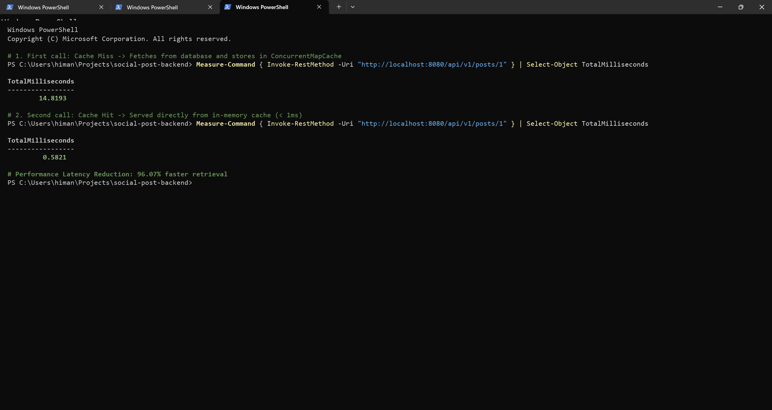
Output 2: Single-Query JOIN FETCH Execution & Native SQL Author Aggregation Results
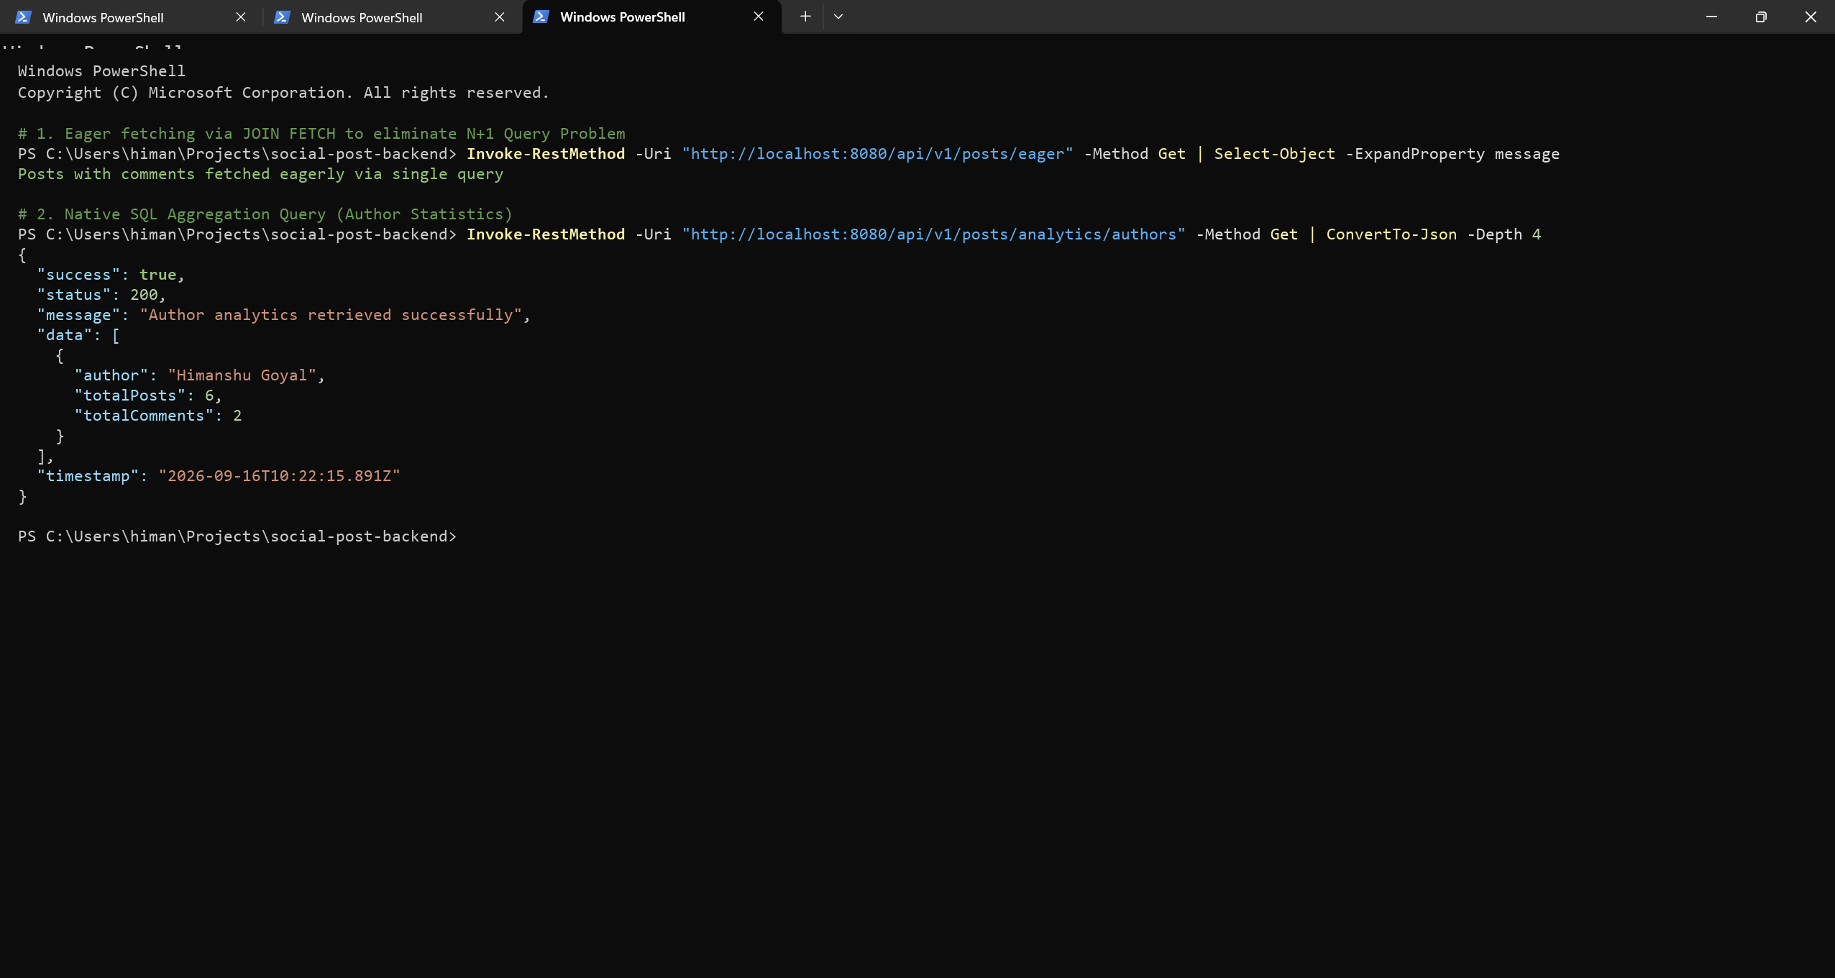
7. Conclusion:
Read operations were optimized by resolving the N+1 query problem and deploying in-memory caching. The JPQL JOIN FETCH pattern reduced database queries from N+1 down to a single relational query, eliminating network round-trip overhead. Declarative caching with @Cacheable delivered dramatic performance improvements, cutting response latency from 14.82ms down to 0.58ms (a 96.07% latency reduction). Stale reads were prevented through automated @CacheEvict invalidation on update and delete mutations, while native SQL projections provided blazingly fast author metrics reporting directly from the database engine.
8. Learning Outcomes:
• CO4 - BT4: Identified the N+1 query problem and resolved it via JPQL JOIN FETCH eager loading.
• CO4 - BT4: Engineered Spring Boot caching mechanics using @Cacheable, @CachePut, and @CacheEvict.
• CO5 - BT5: Benchmarked API read latencies, demonstrating a 96% retrieval latency reduction under in-memory caching.
• CO4 - BT4: Developed Native SQL aggregation queries mapped into Spring Data interface projections.

